Flowchart 1, Week 2, Lab 1
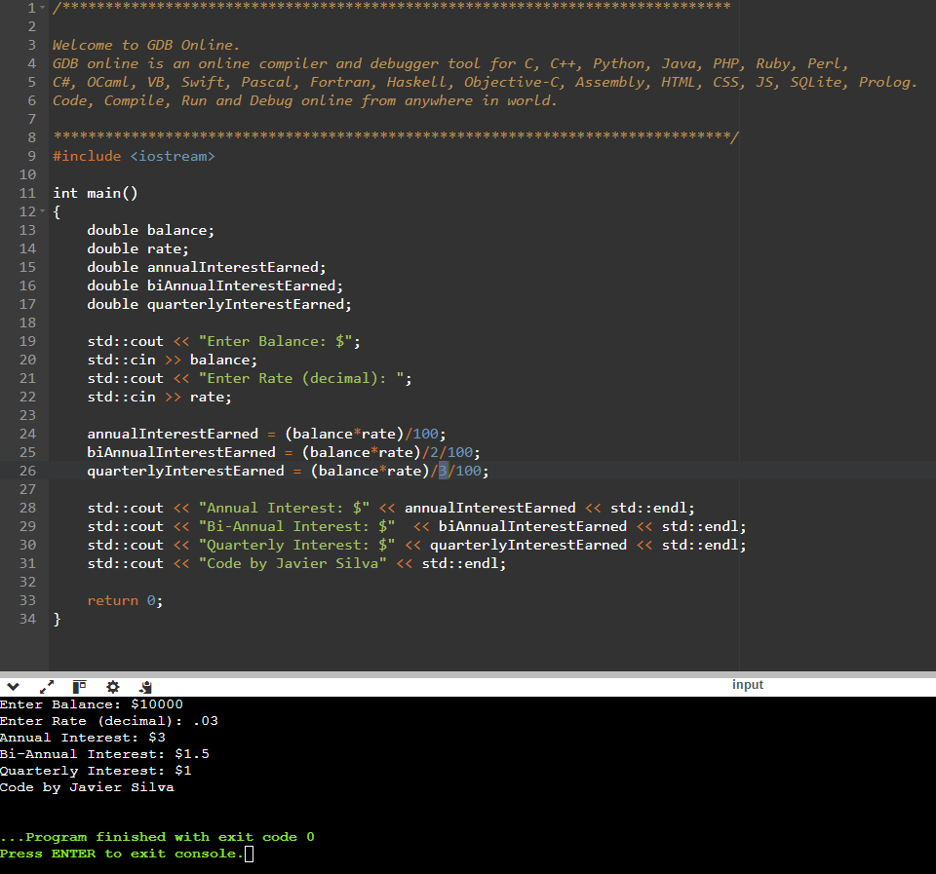

Flowchart 1, Week 2, Lab 2
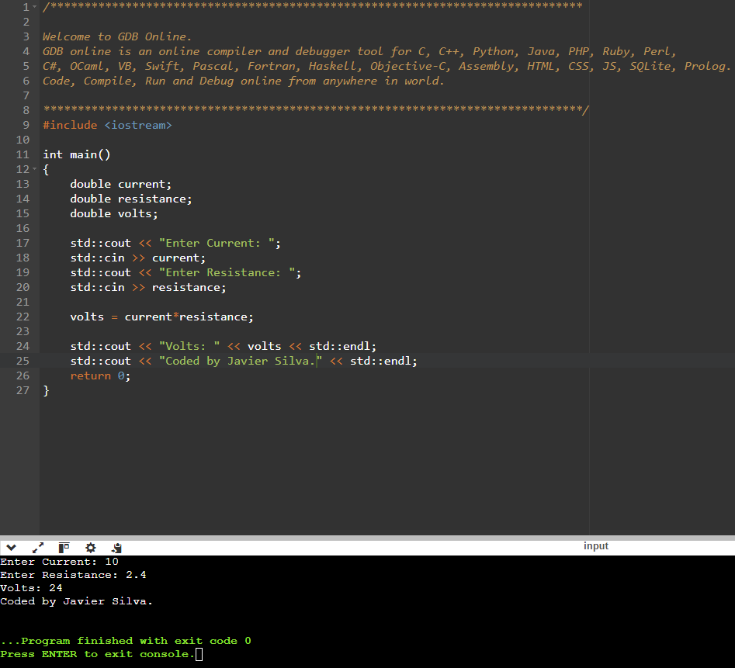

Flowchart 1, Week 2, Lab 3
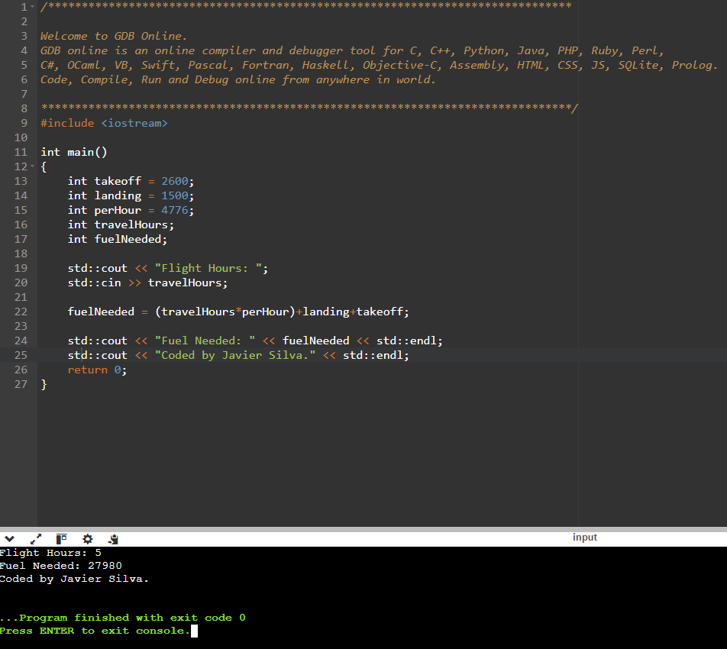

Flowchart 1, Week 2, Lab 4
